Bevill State Community College
APA Reference List Online Sources

APA Reference List
ONLINE SOURCES
APA style is a set of guidelines established by the American Psychological Association for presenting written research. See: The American Psychological Association. (2010). Publication manual of the American Psychological Association (6th ed.). Washington, DC: American Psychological Association.
Copies of this manual are available at the BSCC Circulation Desk (REF BF 76 .7 .P83 2010) at:
• www.apastyle.org • www.bscc.edu/library

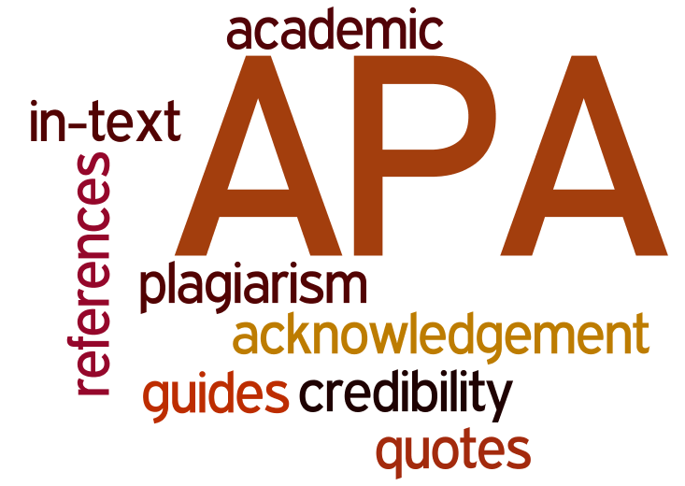

WORLD WIDE WEB SOURCES
When possible your citation should include:
• author • date of publication or update • web page or document title • website URL (use n.d. if not available)

Page or document from a website
APA Manual 7.01 #8, 11 (p. 200) 7.11 (p.215)
Hopson, K. (2007, January 4). Mott Children’s Hospital ranked top children’s hospital in state by Child Magazine. Retrieved from http://www.med.umich.edu/opm/newspage/2007/ childmag.htm
Kane, E. (1999). Dendroica kirtlandii. Retrieved from http:// animaldiversity.ummz.umich.edu/
Parts of Citation
Name of author. (Date of publication). Title of document. Retrieved from Document URL
TIP: When the URL is longer than one line, make a break after a slash or before a period. When there is no author, begin a reference with the title of the webpage.

Government publication
APA Manual 7.03 #31 (p. 205)
United States. Department of Justice Office of Community Oriented Policing Services. (2002). Creative partnerships: Supporting youth, building communities. (Publication No. J36.2:IN6/P25). Retrieved from http://purl.access.gpo.gov/GPO/LPS24105

Parts of Citation
Country. Sponsoring agency. (Date of publication). Publication title. (Publication Number). Retrieved from Publication URL
Journal Article
APA Manual 7.01 #1–5 (pp. 198–199)
Gugajew, S. (2008). A method to the creative madness. Journal of Integrated Marketing Communications, 7, 12-18. Retrieved from http://jimc.medill.northwestern.edu/ JIMCWebsite/site.htm
Parts of Citation
Name of author. (Year of publication). Title of article. Title of Journal, volume number(issue number), page range. doi:xxxx (if not available, include journal URL).

Magazine article
APA Manual 7.01 #8 (p. 200)
Gleach, F. W. (2006, November). The ritual world of Pocahontas. Natural History. Retrieved from http://www. naturalhistorymag.com/1106/1106_feature.aspx
Parts of Citation
Name of author. (Publication date). Title of article. Title of Magazine website, volume number. Retrieved from Article URL
Newspaper article or newswire
APA Manual 7.01 #11 (p. 200)
Carr, C. (2006, November 19). Computer support technicians who play well with others. New York Times. Retrieved from http://www.nytimes.com/
Parts of Citation
Name of author. (Publication date). Title of article. Title of Newspaper website. Retrieved from Article URL

LIBRARY RESEARCH DATABASE SOURCES
Many articles in research databases are identical to their print version, so it is not necessary to provide database information. However, if an article can only be found in a database, then include the database URL.
Digital Object Identifier (DOI)
A DOI is a unique number assigned to some journal articles and books available electronically. Magazine and newspaper articles are not assigned DOIs. APA requires citations for journals and books to include a DOI, if it is available. Find the DOI on the article or look up the DOI with the author name and article title at http://www.crossref.org/guestquery

Journal article
APA Manual 7.01 #1–5 (pp. 198–199)
Smeaton, G. L., & Josiam, B. M. (1998). College students’ binge drinking at beach-front destinations during spring break. Journal of American College Health, 46, 247-251. doi:10.1080/07448489809596000
Parts of Citation
Name of author. (Year of publication). Title of article. Title of Journal, volume number(issue number), page range. doi:xxxx (if available)
TIPS: Multiple Authors
List up to seven authors. For more than seven authors, list the first six authors, then use an ellipsis (...) and the last author listed.
Include the issue number only if every issue begins on page 1.

Magazine article
APA Manual 7.01 #8 (p.200)
Padget, T., & Desvarieux, J. (2010, March 8). Hope for Haiti’s kids. Time, 175(9), 36.
Parts of Citation
Name of author. (Date of publication). Title of article. Title of Magazine, volume number(issue number), page range.

Magazine article with no author
APA Manual 7.01 #8 (p.200)
Magnets that move moods: New treatment for depression. (2002, June 24). Newsweek, 139(25), 57.
Parts of Citation
Title of article. (Date of publication). Title of Magazine, volume number(issue number), page range.

Newspaper article or newswire
APA Manual 7.01 #11 (pp. 200–201)
Glauber, B. (1998, February 14). American college students aren’t in a class by themselves on drinking. The Dallas Morning News, p. C11.
Parts of Citation
Name of author. (Date of publication). Title of article. Name of Newspaper, page range.

Encyclopedia article
APA Manual 7.02 (p. 202)
Nordenson, N., & Odle, T. (2006). Blood sugar tests. In Gale encyclopedia of medicine. (3rd ed., Vol. 1). Retrieved from http://www.gale.cengage.com/gvrl/
Parts of Citation
Name of author. (Year of publication). Title of entry. In A. Editor & B. Editor (Eds.), Name of encyclopedia. (xx ed., Vol. xx). Retrieved from database URL

eBook
APA Manual 7.02 #19 (p. 203)
Papadopoulos, A., & La Fontaine, J. (2000). Elder abuse: Therapeutic perspectives in practice. Retrieved from http://netlibrary.com/
Parts of Citation
Name of author. (Year of publication). Title of book. Retrieved from database URL

Article or chapter in an eBook
APA Manual 7.02 #24 (p. 204)
Leeper, B. (2006). Cardiovascular system. In M. Chulay & S.M. Burns (Eds.). AACN essentials of critical care nursing. Retrieved from http://online.statref.com/
Parts of Citation
Name of author. (Year of publication). Title of article. In A. Editor & B. Editor (Eds.), Title of book. Retrieved from database URL

Articles only available in research databases
Lamoureux, F. (2010). Indonesia: Traditions and etiquette. In World Geography. Retrieved from http://www.worldgeography.abc-clio.com
Reid, N. C., & Williams, R. G. (2008). Coast type. In Encyclopedia of marine science. Retrieved from http://www.fofweb.com/
Parts of Citation
Name of author. (Date of publication). Title of article. In Title of book/database. Retrieved from database URL
TIP: Other research databases which would follow this format include CultureGrams, Issues and Controversies, Today’s Science, ERIC, Science Online, and Vocational Biographies.

